**MOBILE COMPUTING ASSIGNMENT PRESENTATION**

NAME: JEEVICKHA K A

ROLL NO: 20PW12

**CENTER EXCITED CELL**

If a mobile network tower is placed near the center of a coverage area, it can provide better coverage to the surrounding area, as the signal is transmitted in all directions from the omni-directional antenna. This can result in a larger coverage area and more consistent signal strength for users within the coverage area.

**EDGE EXCITED CELL**

The placement of towers on three of the six corners of a given area, with sectored directional antennas, is a common approach used by cellular network operators to optimize coverage and performance in that area. By using directional antennas, the network operator can focus the signal in specific directions and reduce interference from surrounding obstacles.

**SMALL CELL / LOW POWERED BASE STATIONS**

A low-powered base station is a type of wireless communication infrastructure that operates at a lower power level compared to traditional base stations. This type of base station is designed to cover smaller geographic areas and to provide targeted coverage in areas where traditional base stations may not be practical or cost-effective.

Low-powered base stations operate at a lower power level, they consume less energy and produce less electromagnetic radiation compared to traditional base stations. This makes them a more environmentally friendly option, as well as a more cost-effective option for mobile network operators.

**ADVANTAGES OF SMALL CELL**

Less Transmission powers

Having long distances between sender and receiver results in even more interference problems. With small cells, mobile stations and base stations only have to deal with local interference.

Cellular systems are decentralized and so, more robust against the failure of single components. If one antenna fails, this only influences communication within a small area.

**DISADVANTAGES OF SMALL CELL**

Cellular systems need a complex infrastructure to connect all base stations. This includes many antennas, switches for call forwarding, location registers to find a mobile station etc, which makes the whole system quite expensive.

The mobile station has to perform a handover when changing from one cell to another. Depending on the cell size and the speed of movement, this can happen quite often.

**FREQUENCY REUSE**

Frequency Reuse is the scheme in which allocation and reuse of channels throughout a coverage region is done. The total capacity of the system is increased without increasing its allocated bandwidth.

The total number of channels are divided into K groups. K is called reuse factor or cluster size. Each cell is assigned one of the groups. The same group can be reused by two different cells provided that they are sufficiently far apart.

Cell with the same number uses the same frequencies.

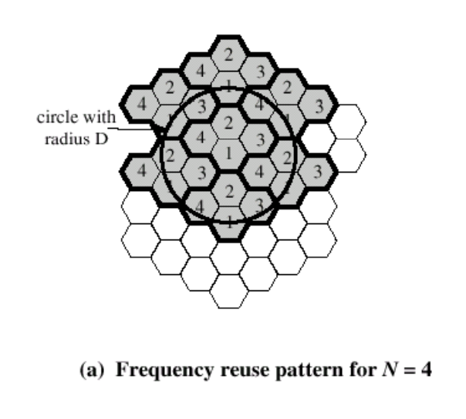

**ADVANTAGES**

Frequency reuse can reduce the cost of building a cellular network since fewer frequency bands are required.

Frequency reuse enables the network to be easily scaled by adding more cells as needed.

**DISADVANTAGES**

Frequency reuse can result in increased interference, particularly in areas where cells are closely spaced. This can reduce the quality of service and network capacity.

Frequency reuse requires careful planning to ensure that cells are appropriately spaced and that interference is minimized. This can make the implementation process more complex and time-consuming.